****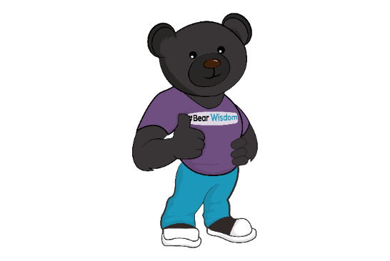**COACHING PACKAGES**

|  |  |  |  |
| --- | --- | --- | --- |
| **DETAILS** | **BASIC** | **STANDARD** | **PREMIUM** |
| **DURATION** | 3 Months | 6 Months | 9 Months |
| **NUMBER OF MEETINGS** | 1 per month | 2 per month | 2 per month |
| Meetings are face to face or via Zoom, depending on your location. Each meeting lasts 90 minutes. |
| **EMAIL SUPPORT** | 1 per month | 2 per month | 3 per month |
| Check progress, updates, success, challenges and queries. |
| **CHECK IN CALL** | 1 per month | 2 per month | 2 per month |
| Via Zoom, lasting a maximum of 30 minutes. Opportunity for updates, deal with challenges, ask questions and share your progress. |
| **POWER UP CALL** | **X** | **X** | 2 per month |
| 15 minutes, via telephone or Zoom. When you need an extra boost; an opportunity to deal with a potential challenge as it arises. |
| **EMAIL MOTIVATION** | **X** | **X** | Daily |
| Motivational messages throughout the week. |
| **INVESTMENT** | £325 pm | £475 pm | £950 pm |
| Any unused calls can be carried forward, similarly unused time (in blocks of 5 minutes) can be accumulated for future calls. | | | |
| Special rates are available for **students, nurses and veterans**, please contact me to find out more. | | | |
| After our initial consultation, if you are new to coaching, you may prefer to invest in a single, one-off session before committing to investing in one of the coaching packages. These are available, please contact me to find out more. | | | |